Create IBM Cloud Account

Team ID | PNT2022TMID11603
Project | Smart Fashion Recommender System

TEAM LEAD - M.S.Shara Banu

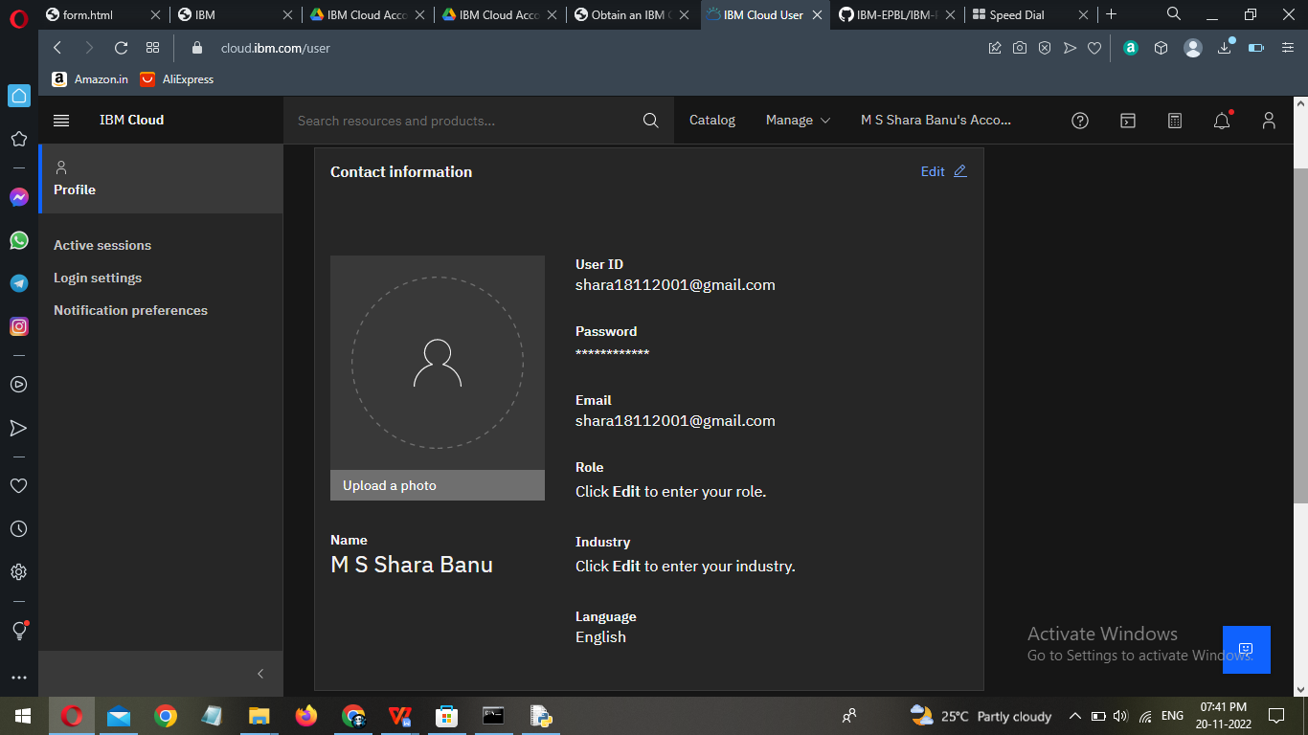

MEMBER 1- V.S.Susmitha

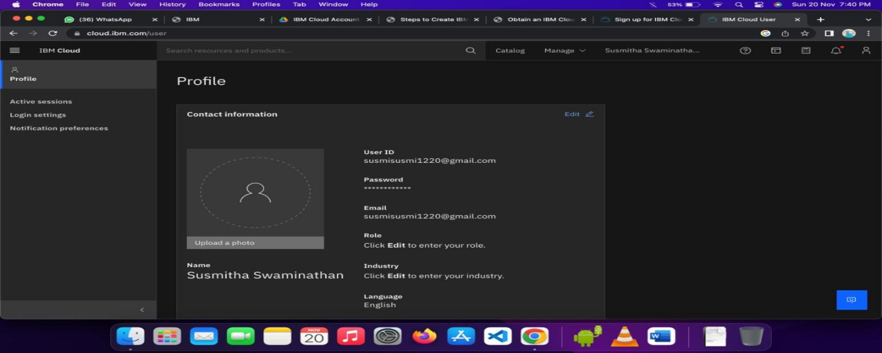

MEMBER 2- R.Vaishnavi

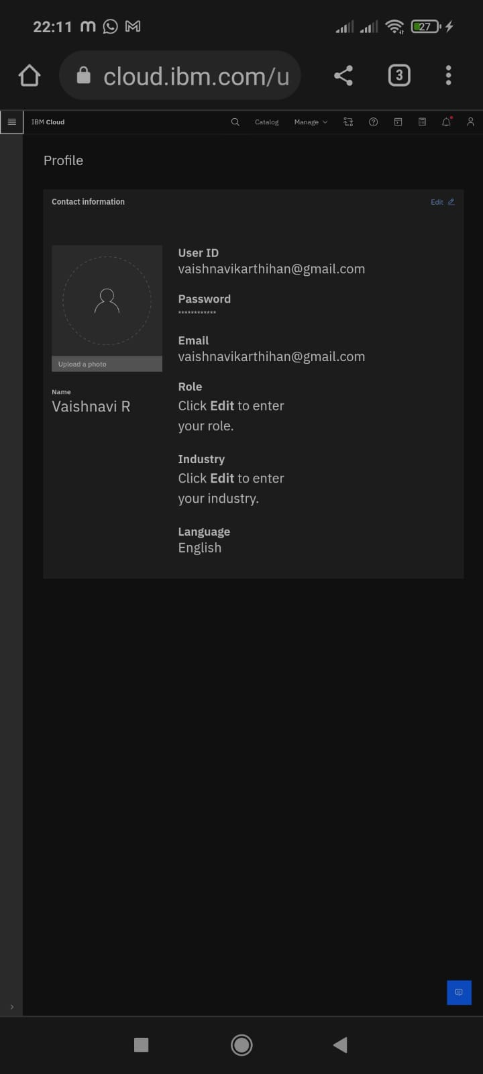

MEMBER 3 -M.Sheshavardhini

